Condominium Booking and Operation Management

System

- CREATE AN ACCOUNT.
If you don’t have an account click the create account button.
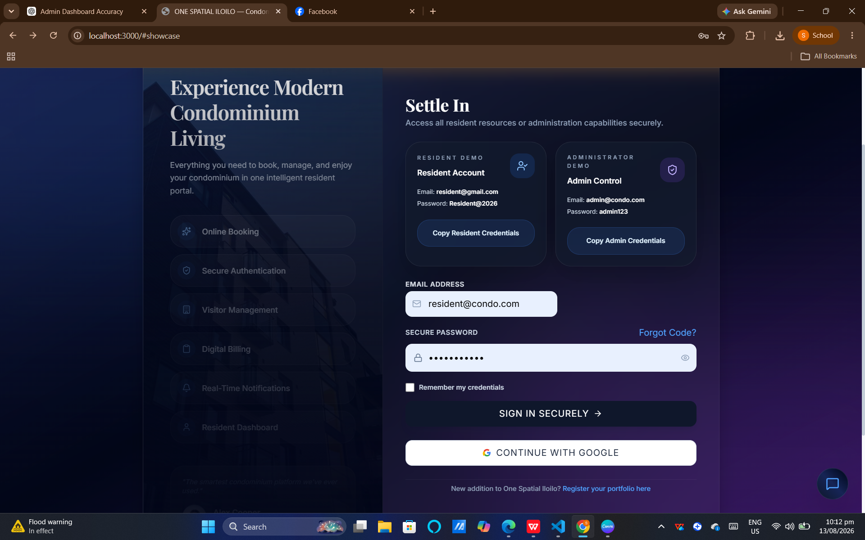

- FILL UP THE FORM.

Here you can fill up your name, number and email address/ password so you can create account.
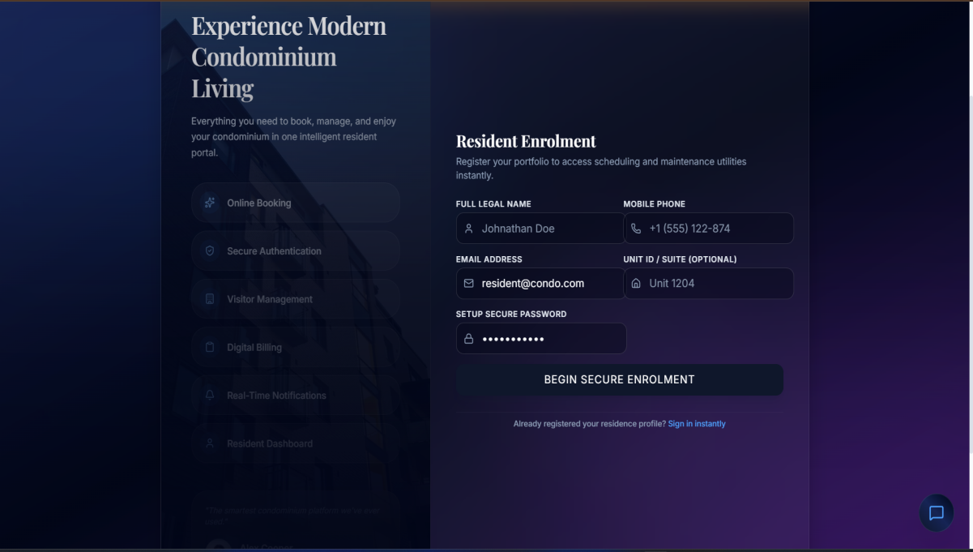

- LOGIN YOUR ACCOUNT.

After you register your account you can now login your account

- BROWSE UNITS

You can choose unit and you can book or inquire.

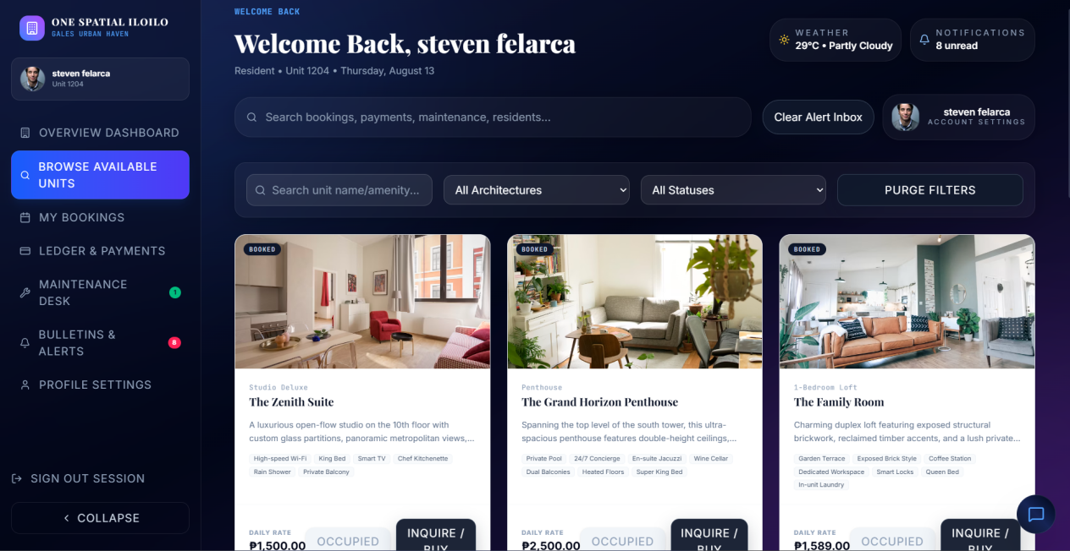

- RESIDENTS BOOKING

In this page you can see your bookings, bill and status of your transaction.

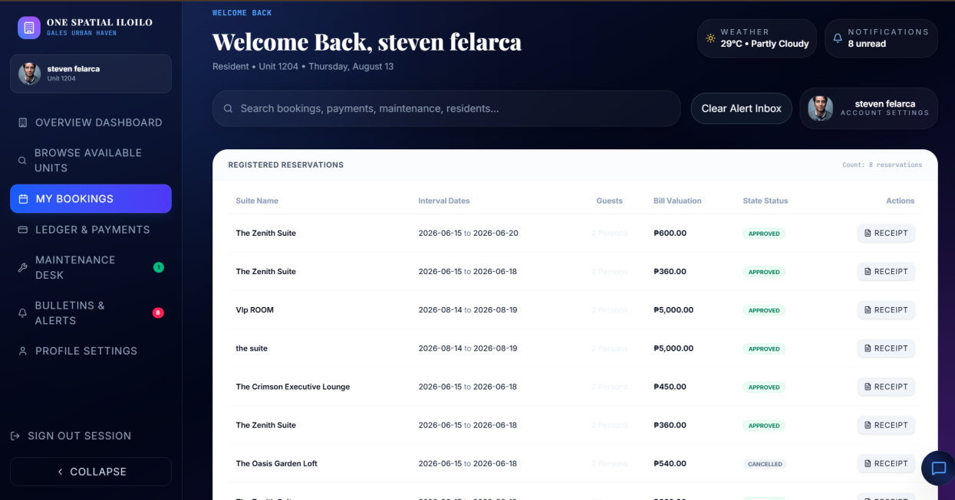

- PAYMENTS

Here you can see your total payments and other remaining that you cant complete to pay.

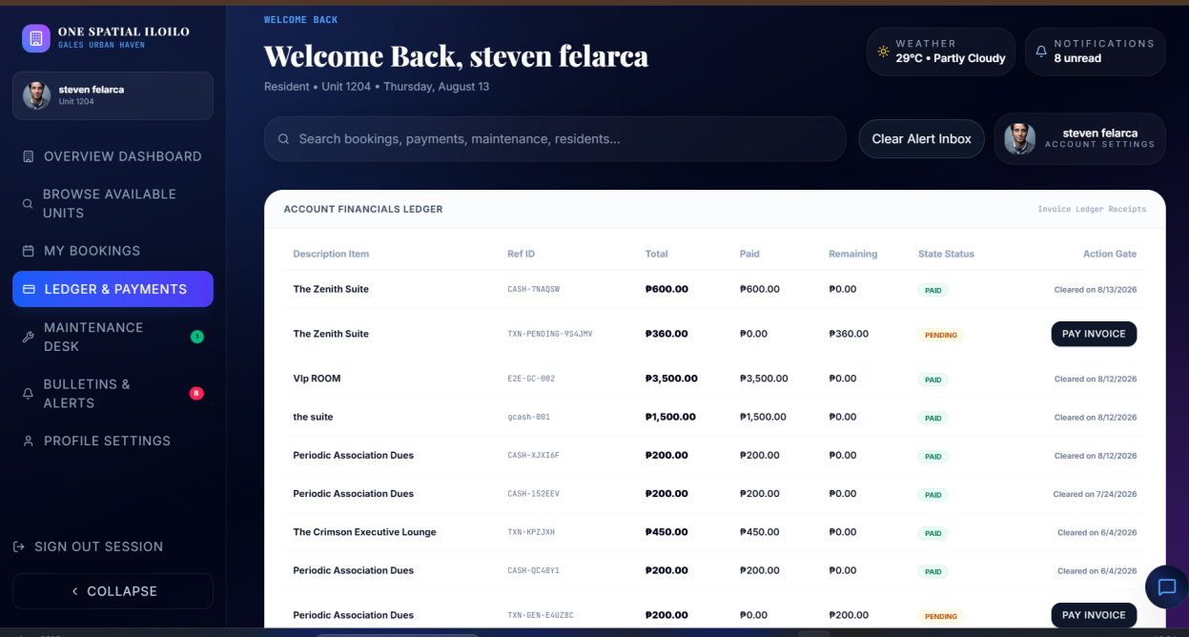

- PROFILE SETTINGS.

In this page you can edit your proﬁle and other information.

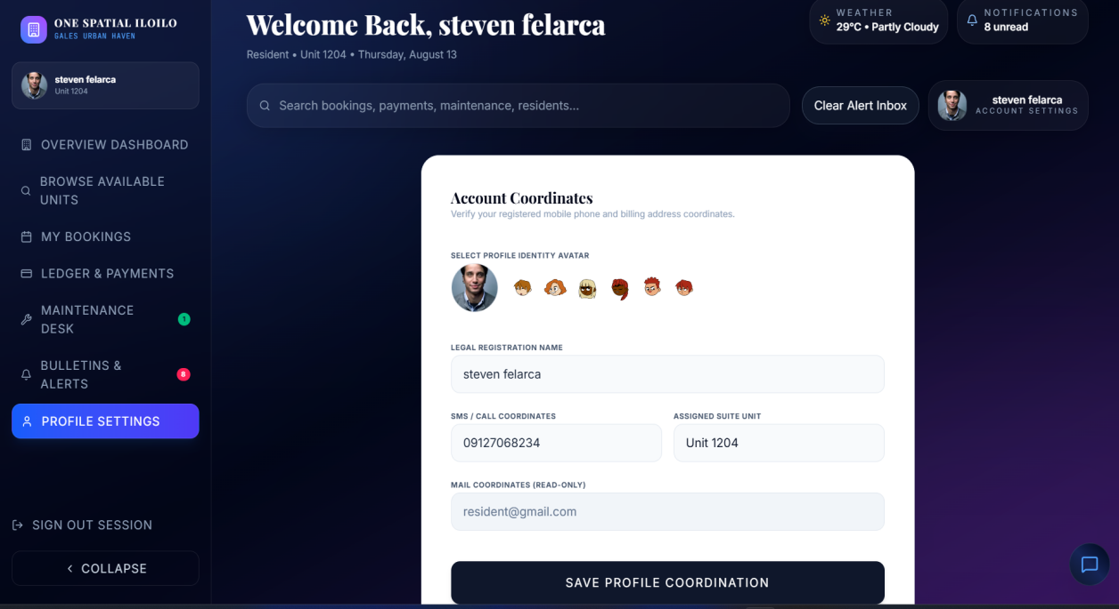

II. ADMIN DASHBOARD

In this page you can see your income, active residents and available condo units.

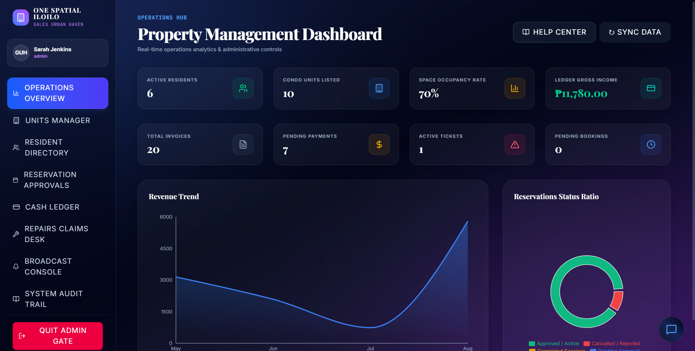

- UNITS MANAGER

Here you can add units, edit and also delete if the units is not available.

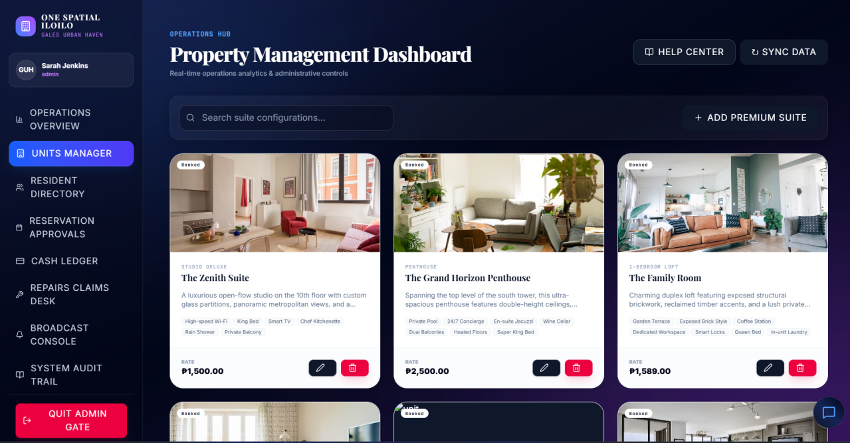

- RESIDENTS PAGE
This is where you can see the records of user activities and system actions, including logins, bookings, payments, and administrative changes.

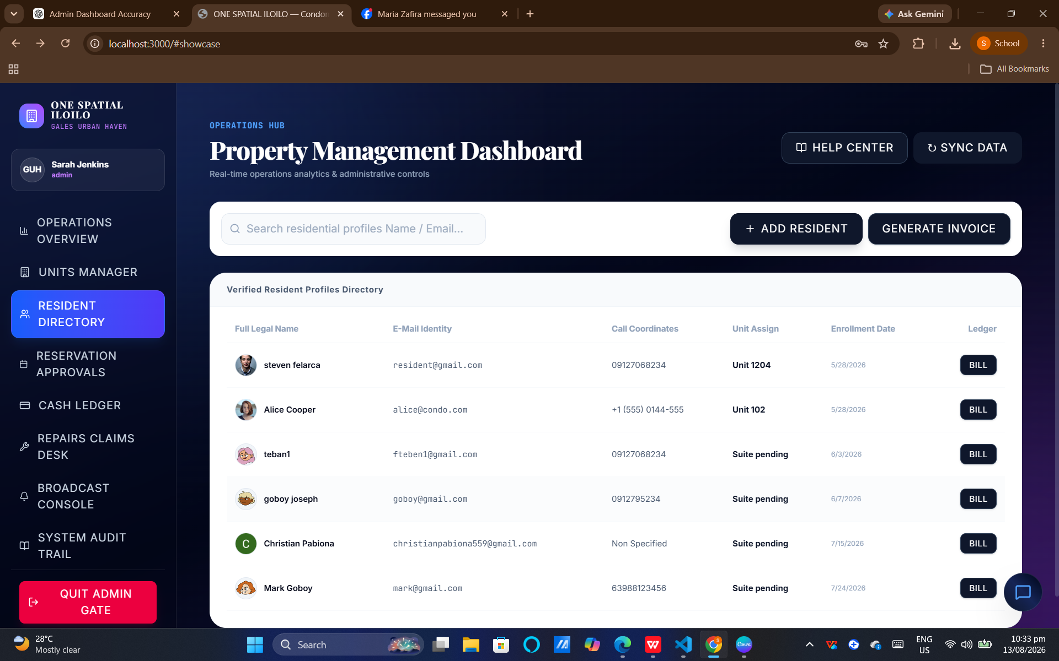

- RESERVATION APPROVALS

Here you can see if the residents want to have reservation you can approve it or decline it.

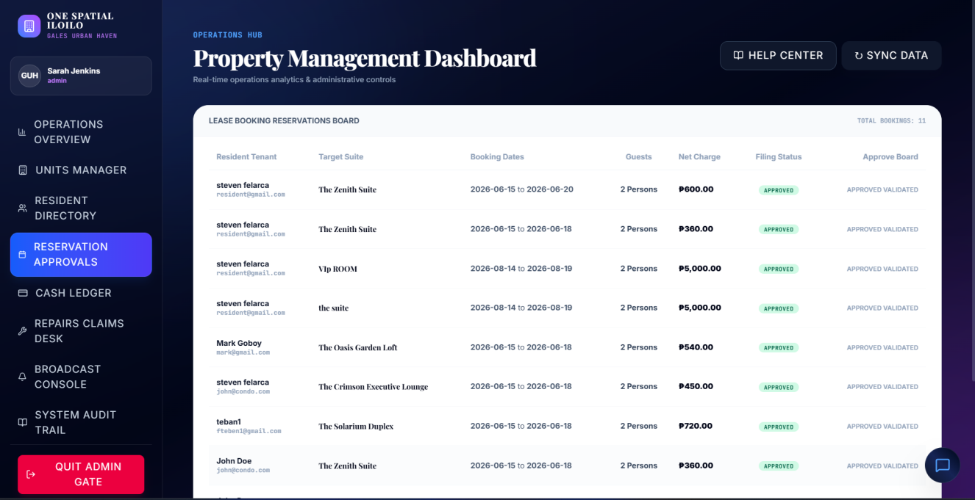

- CASH LEDGER

Here you can see the net balance and the status of the residents payment.

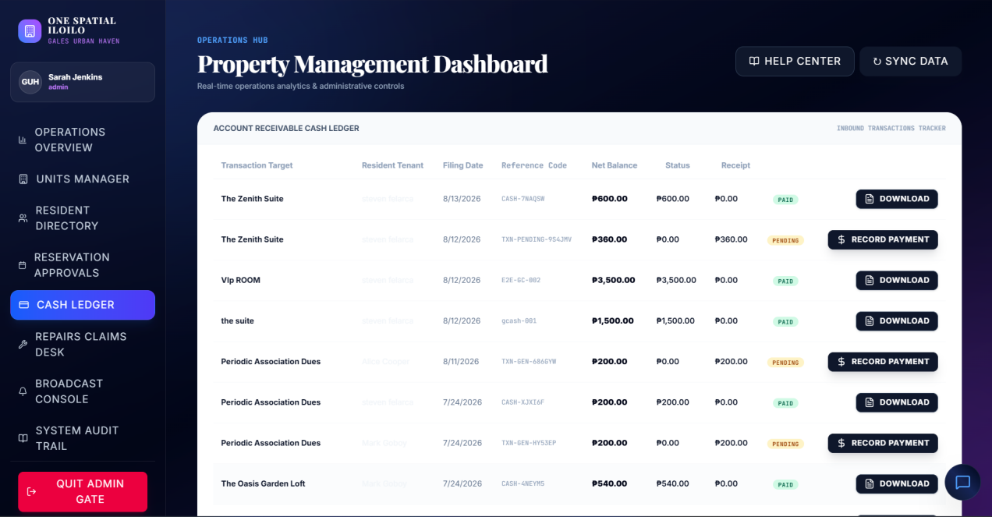

- SYSTEM AUDIT TRIAL

In this page you can track every admin action for transparency, security, and accountability.

